PRUEBA SABER 11

PARTE 3

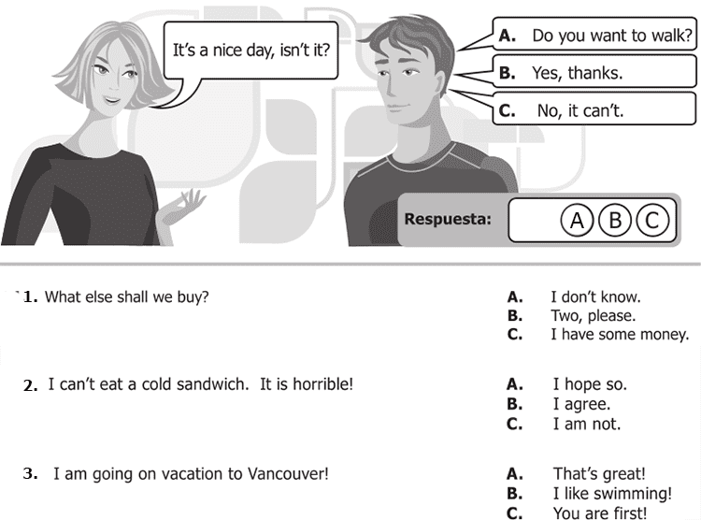

**7.** I can’t eat a cold sandwich. It is horrible! A. I hope so

x. I agree

C. I am not

**8.** I am going on vacation to Vancouver! x. That´s great!

B. I like swimming

C. You are first

**9.** It rained a lot last night! A. Did you accept?

B. Did you understand?

x. Did you sleep?

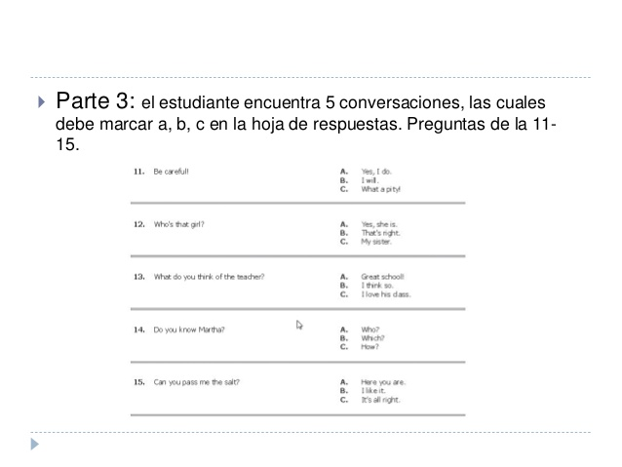

11.A. X

B.

C.  
12. A.

B.

C.X  
13. A.X

B.

C.  
14. A.x

B.

C.

15.A.

B.x

C.

PRUEBA SABER 11

PARTE 4

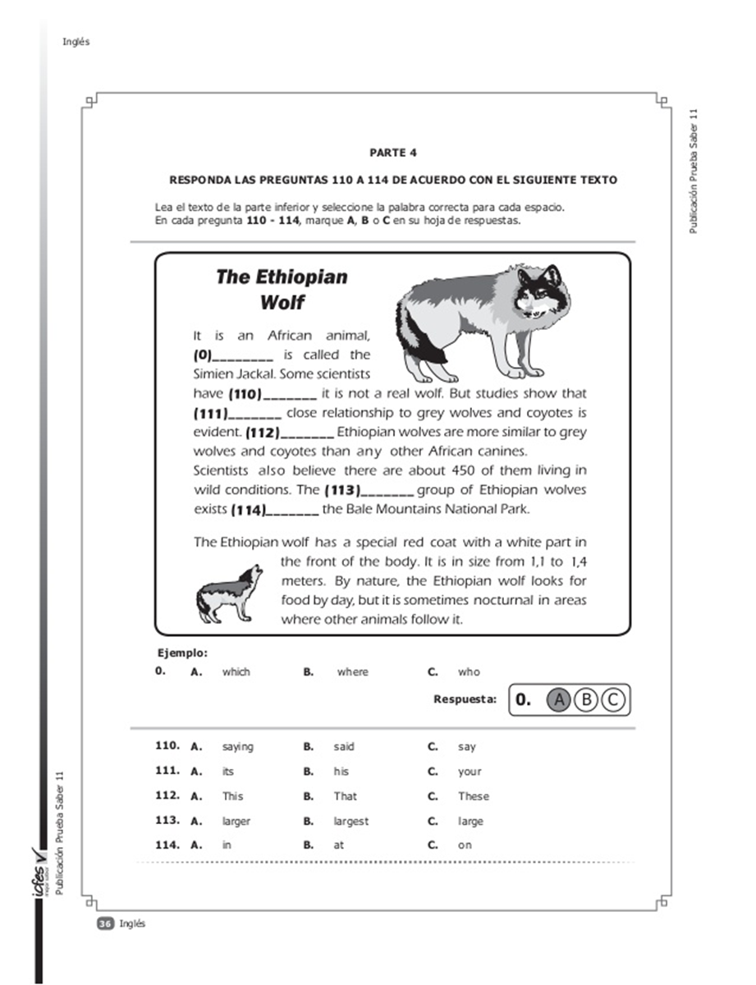

110.C

111.A

112.A

113.C

114.B

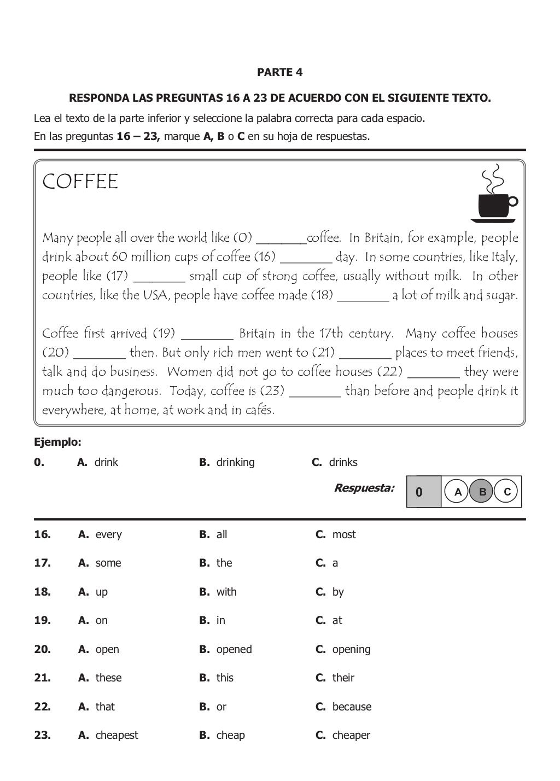

16.B

17.B

18.B

19.B

20.A

21.B

22.A

23.C